Ideation Phase
Define the Problem Statements

Date | 19 February 2026
Team ID | LTVIP2026TMIDS35300
Project Name | Civil Engineering Insight Studio
Maximum Marks | 2 Marks

Customer Problem Statement Template:
Problem Statement: Civil engineers often face the challenge of manually describing structures based on images, which can be time-consuming and subjective. Without automated tools, generating detailed descriptions of civil engineering structures, including types, materials, dimensions, construction methods, and notable features, requires significant human effort and expertise. To address this challenge, there is a need for an efficient and reliable tool that can automatically analyze images of civil engineering structures and generate insightful descriptions, enabling engineers to make informed decisions and communicate effectively about their projects.
Scenario 1: Material Identification in Building Construction
A construction supervisor overseeing a building project utilizes the Civil Engineering Insight Studio to identify materials used in the building's construction. The supervisor uploads an image of the construction site and prompts the tool to identify construction materials such as concrete, steel, and bricks. The tool analyzes the image, identifies various materials, and provides a comprehensive list with descriptions of each material's type, quantity, and location within the structure.
Scenario 2: Project Progress Documentation for Construction Firm
A civil engineering firm engaged in documenting ongoing construction projects utilizes the tool to streamline project documentation. Project managers upload images of construction sites and prompt the tool to document project progress, including descriptions of completed and planned structural elements. The tool analyzes the images, generates detailed documentation of completed structural elements, materials used, dimensions, construction methods, and planned phases of work, facilitating effective project management and communication within the firm.
Scenario 3: Structural Analysis of Bridge
In this scenario, a civil engineer tasked with assessing the structural integrity of a bridge uploads an image of the bridge to the Civil Engineering Insight Studio. The engineer requests an analysis of the bridge's structural components, including beams, columns, and trusses. The tool processes the image, identifies key structural elements, and generates detailed descriptions of each component's material, dimensions, and construction methods. Additionally, the tool highlights any notable features or engineering challenges observed in the structure.

Example:
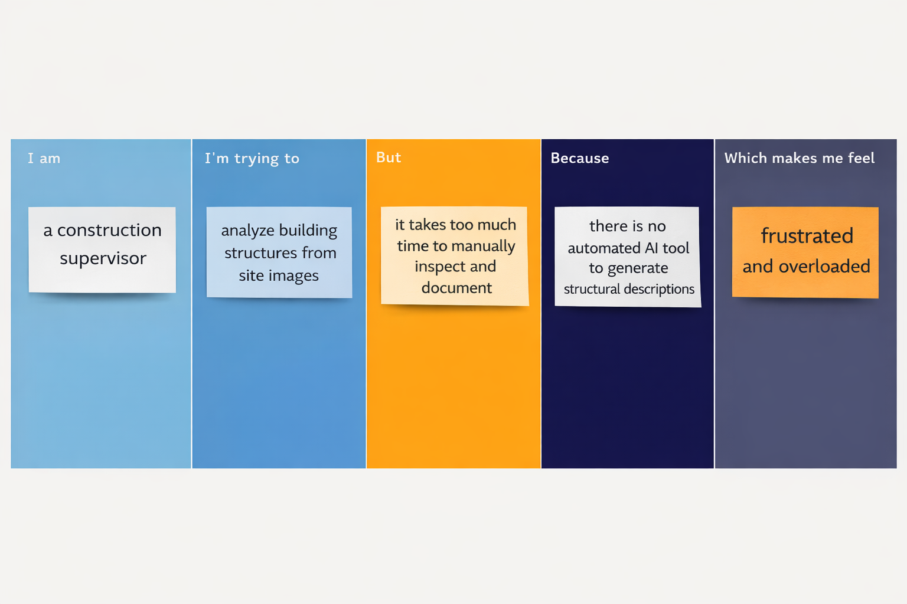
Problem Statement (PS) | I am (Customer) | I’m trying to | But | Because | Which makes me feel
PS-1 | I am a civil engineering student | I’m trying to understand real-world structures from images | But I lack experience to identify materials and construction methods correctly | Because learning resources are mostly theoretical | Confused and less confident
PS-2 | I am a civil engineering project manager | I’m trying to document project progress accurately | But creating detailed structural descriptions from images is difficult and subjective | Because there is no automated system to analyze and generate structured reports | Stressed and concerned about reporting accuracy

